You must meet the prerequisites below to link/bind your PIV credentials to your VistA account(s):
- Have Access and Verify codes for VistA accounts. If you do not have your Access and Verify codes or do not remember them, contact the Enterprise Service Desk at 855-673-4357 or TTY (Hearing Impaired Only) 512-326-6638, to have the codes reset. These lines are available 24 hours a day, 7 days a week.
- Have PIV card PIN. If you do not remember PIN or experience any other issue, visit your local PIV office.
To link/bind your PIV credentials to your VistA account(s), follow these steps:
- Close all open applications and browser windows.
NOTE: You may experience a failure to link/bind your account(s) if you are logged into CPRS and your VistA application. If this occurs, you should log out and not log back into CPRS until you receive an email stating your account is linked.
- Open Internet Explorer and navigate to the IAM Provisioning Service Link VistA to User task.
- If you are not already logged into a Single Sign-On (SSO) application, the site will prompt you to log in.
  - Click the Sign In with VA PIV card button.
NOTE: If you have a PIV exemption or are between PIV cards, refer to KB0013706 for logging into SSOi applications using Windows authentication.
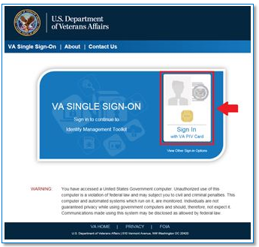
  - Select your certificate (Certificate should read Authentication. Issuer: Veterans Affairs User CA B1.)
  - Enter PIN.
    - If you receive the following errors after logging in, please see the indicated knowledge article for resolution, and continue to Step 4 below:
    - Page Cannot Be Displayed: Verify the correct Internet Explorer settings, required by the VA for PIV use (KB0013570).
    - You are in compatibility mode and certain features in the TK will not work as expected: Turn off compatibility view (KB0013476)
- The VA Onboarding Service homepage will open. If there is a pop-up box asking you to select your role, close the box to continue.
- Click the Request Access Link on the left navigation bar.
- On the page that opens, select Other IAM Provisioning
- The Link VistA to User task window will open. If it does not, click LINK VISTA USER from the navigation links on the left.
NOTE: After selecting Link VistA user, the message "No vista stations linked to your account in provisioning", will display. This message can be ignored.
- From the Link Account drop-down menu, select the appropriate instance of VistA. You can type into the station list to jump to a specific instance.
NOTE: The VistA instance list is sorted by station number. If station ends in a letter or contains a letter, select the parent station for your division. For example, if your station is 576A or 576A5, select 576 station number.
- Enter your VistA/CPRS Access Code and Verify Code for the selected VistA instance.

- Click Submit.
If you experience any issues or are unable to complete the linking/binding process, contact the Enterprise Service Desk using one of the methods listed below:
  - Self-Service: Create Incident
  - Phone: 855-673-4357
  - TTY (Hearing Impaired Only): 512-326-6638
These lines are available 24/7

